|  |  |
| --- | --- |
| **Project Name** | STOCK CHECKER |
| **Objective** | STOCK CHECKER:  Stock Informer is the real time stock checker that helps you to track down those  hard to find products. You can add, delete and update the stocks from your account  Stock checker brings a peculiar amount of significance in the stock market area. |
| **Platform** | Web-app |
| **Front End** | Django |
| **Back End** | Sqlite3 |

TABLE OF CONTENTS:

1. OBJECTIVE
2. ABSTRACT
3. HARDWARE REQUIREMENTS
4. SOFTWARE REQUIREMENTS
5. FUNCTIONAL SPECIFICATIONS

* USER SPECIFICATION
* MODULE SPECIFICATION

1. ER DIAGRAMS
2. UML DIAGRAMS
3. CLASS DIAGRAMS
4. DATA DICTONIARY

10.POST IMPLEMENTATION

11.FUTURE ENHANCEMENTS

OBJECTIVE:

Stock Informer is the real time stock checker that helps you to track down those

hard to find products. You can add, delete and update the stocks from your account

Stock checker brings a peculiar amount of significance in the stock market area.

ABSTARCT:

The best part of STOCK CHECKER is that you find all the international stocks and able to get the tip of the stocks. It can check the previous stocks and can tell you that how safe the stock is and the momentum it's bringing to the user.

**FUNCTIONAL SPECIFICATIONS:**

**User Specification:**

Admin: He can add stocks, manage stocks and know the performance of each and every stock and also view stock and enquiry.

User: He can view his tasks, performance report and also give feedback.

Search: This is a unique search module where the user can know about his stocks and get detailed information.

**HARDWARE REQUIREMENT**

**Client side:**

|  |  |
| --- | --- |
| **RAM** | 2-4 GB |
| **Hard disk** | 10 GB |
| **Processor** | 2.0 GHz |

**Server Side:**

|  |  |
| --- | --- |
| **RAM** | 2-4 GB |
| **Hard disk** | 20 GB |
| **Processor** | 2.0 GHz |

**SOFTWARE REQUIREMENT**

**Client side:**

|  |  |
| --- | --- |
| **Web Browser Google, Mozilla Firefox etc.** |  |

**Server side:**

|  |  |
| --- | --- |
| **Web Server** | Django server  (http://127.0.0.1:8000/) |
| **Database Server** | Sqlite3 |
| **Other Softwares** | PYCHARM IDE |

**E-R DIAGRAM**

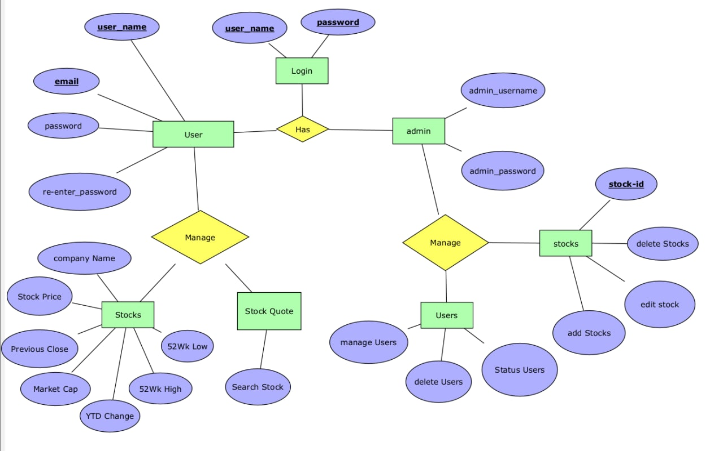

**UML DIAGRAMS**

* **Use Case Diagram**

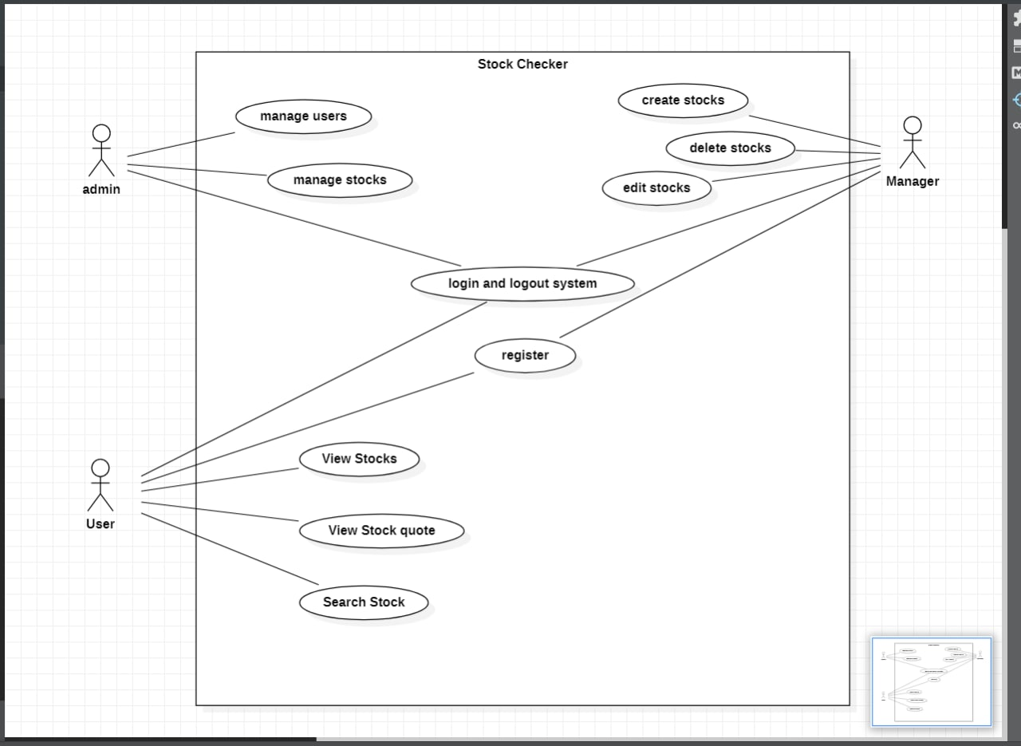

**Class Diagram**

* 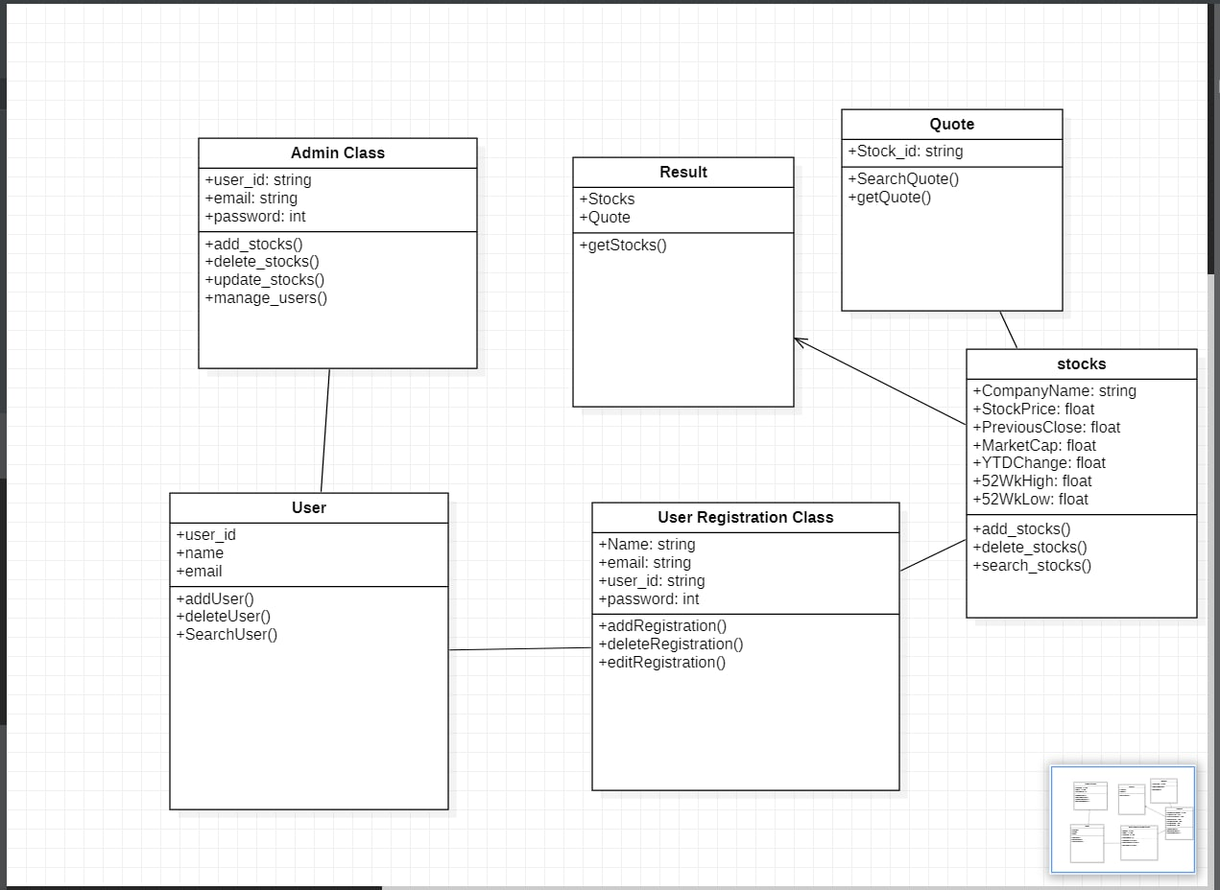

DATA DICTIONARY:

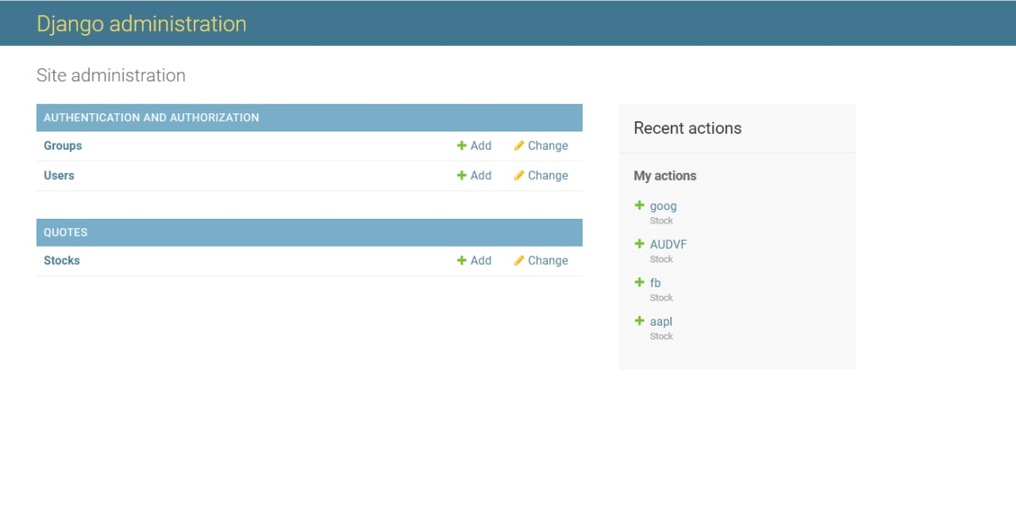

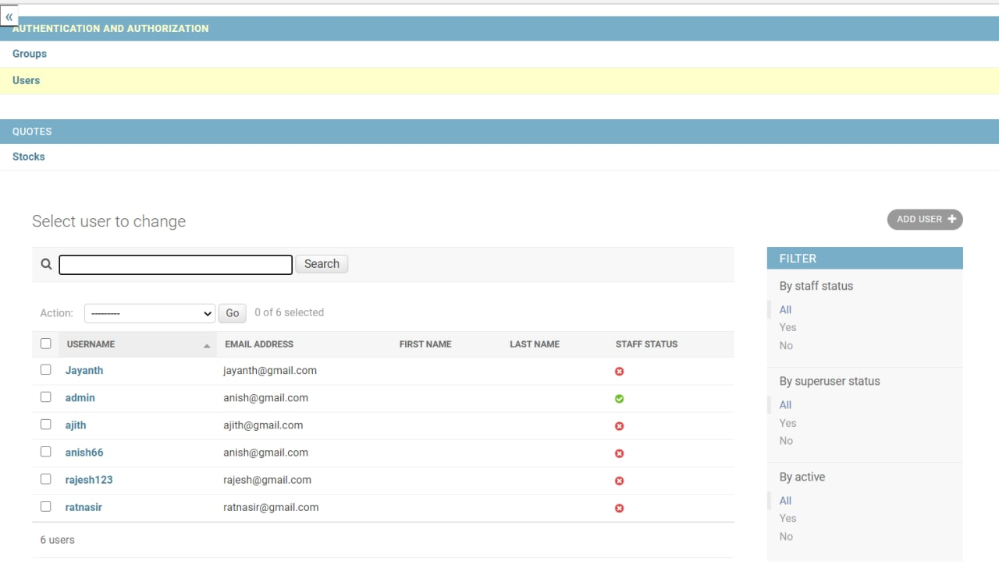

POST IMPLEMENTATION:

* The website application is self maintained .
* There is no need provide post implementation support.
* The admin can access add, edit, delete process.
* **FUTURE ENHANCEMENT**
* Add new Interesting stocks
* Creating more detailed analysis for user regarding stock market.